***STORE***

ITEMS_IN_STOCK()

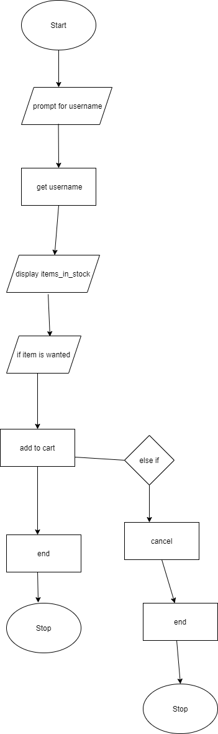

PRE_ORDER()

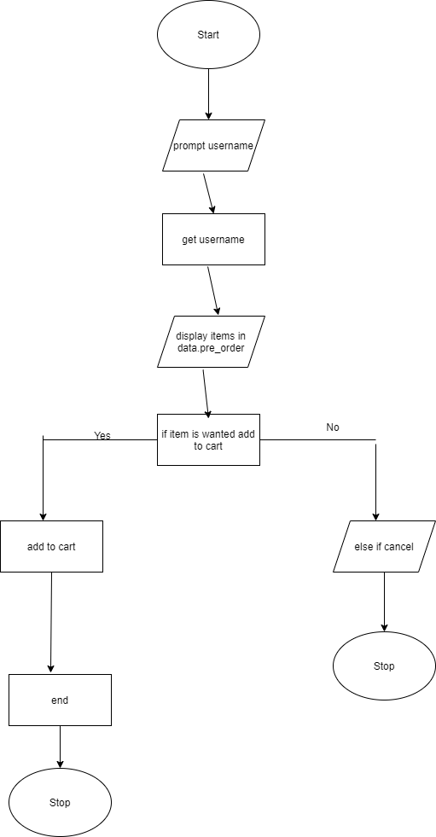

ITEM_IN_STOCK()

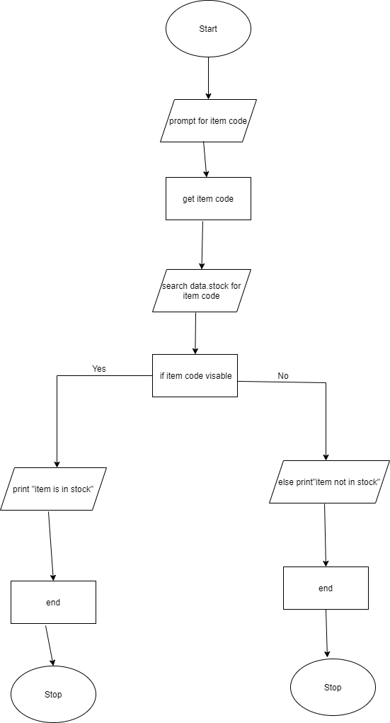

NEW_ARIVALS()

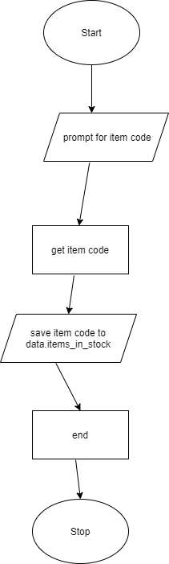

REMOVE_ITEM()

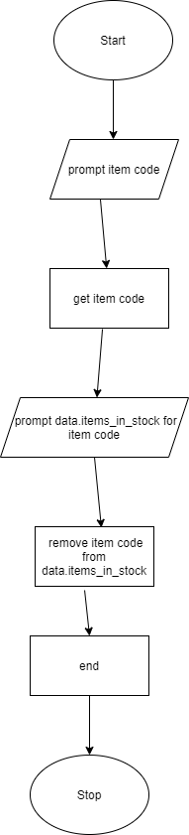

***COMMUNITY HUB***

SOCIAL_MEDIA()

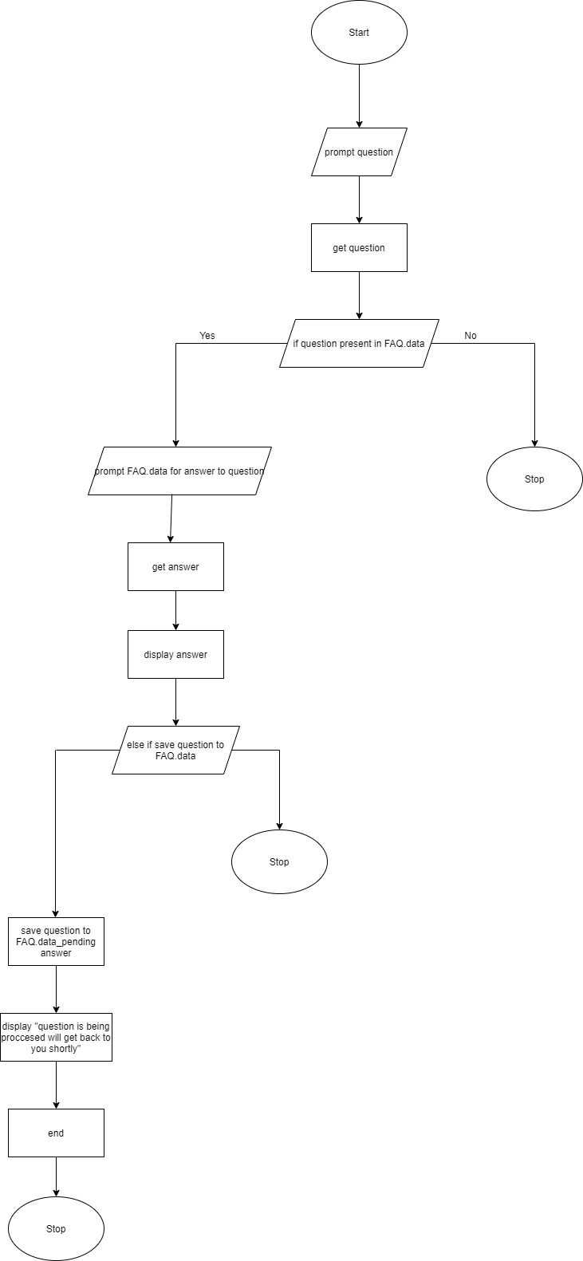

WEBSITE()

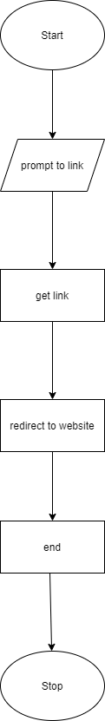

HELP

AI_ASSISTANT()

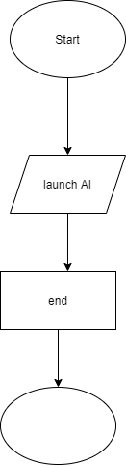

REWARDS

SUBSCRIPTION()

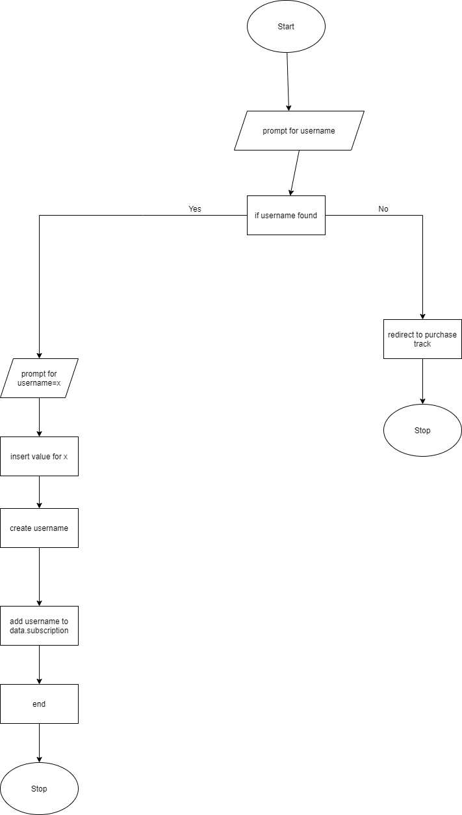

PURCHASE TRACK()

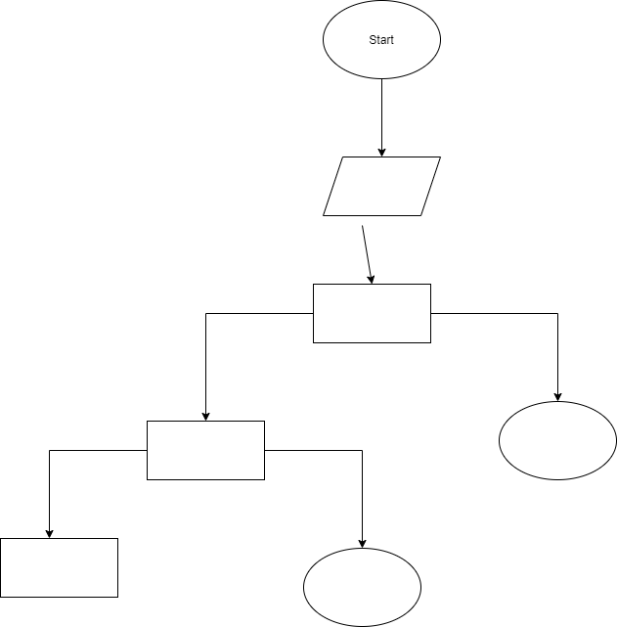

FEEDBACK

REVIEW()

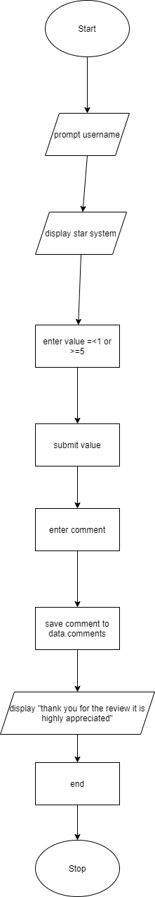

SURVEY()

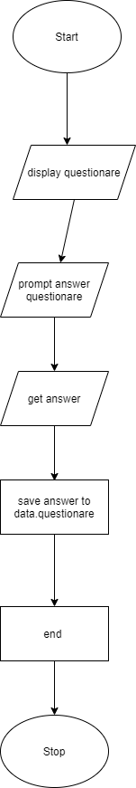

HUMAN RESOURCES

CUSTOMER_CARE_LINE()

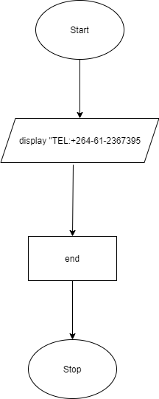

COMPLAINTS()

